Lab 1

**NB: All blogging must be your own work. There should be no copying and pasting from websites, colleagues or anywhere else.

Part I – Beginning Web Development (record in blog)

- Create a blog to document your Web & User Interface lab work.

- Use Blogger - http://blogger.com to set up your own blog. Follow their instructions to establish your blog. Send the link of your blog to andrea.f.curley@tudublin.ie (eg. yourname.blogspot.com)

- Your blog will be the place where you record information from your labs (not your html code, though snippets of html maybe required).

- Create a Twitter account (if you don’t have one) on http://www.twitter.com and follow dt265. To message me, put @dt265 before your message.

Read the following two articles and discuss two interesting observations from each article. (~50 words/observation)
- All you need to know about mockups, wireframes, and prototypes - Wireframing vs. prototyping: What’s the difference?
https://www.invisionapp.com/inside-design/wireframe-prototype-difference/
Discuss TWO observations from this article.

Wireframing and protoyping of webpages are two distinct processes when designing a product. Main difference is that a prototype is closer to the finished product. i.e. Wireframing ⮕Prototyping ⮕Final Product. The author describes the wireframe as the skeleton and the prototype as a visual representation of the final product.
The author recommends sketching on paper as a helpful way of getting designs /ideas out of your head and onto the operating table. Coming from a mechanical engineering background, I cannot overstate the importance of just sketching a design on paper. No matter how high level and crude, or low level and detailed, sketching a design on paper will give you a starting place where the design can evolve from.

The 10 Most Common Web Design Mistakes
https://wparena.com/common-web-design-mistakes-to-avoid/
Discuss TWO observations from this article.

The first common mistake they mention in this article is that of slow loading webpages. I think this is an interesting mistake, as, even though computing power is still getting cheaper and cheaper (both on the industry side i.e., web servers, and on the user side i.e., the phone or laptop being used to view the page), the fundamental issue of loading time persists. It doesn’t matter how fancy your graphics and transitions are on a webpage, if it takes more than a couple of seconds to load the user is going to go elsewhere.
From personal experience I have definitely ran into mistake no. 5 – No Contact Information on sites before. Nothing more frustrating than trying to find a phone number or address and having to drill down through multiple pages looking for it (a lot of the time then turning to Google Maps to find it instead…)

- Pick one term/technology from each of the two articles in 3 (one from 3a and one from 3b):

  - Using Twitter: Do a search on each term, documenting information you found and where you found it from. (~50 words/technology).
Article a. – Keyword “Wireframe”
One of the results I got on Twitter was an infographic with “10 Principles of Effective UI Design”. However, I think this is quite ironic as the infographic itself is not very well designed from a UI point of view, as the numbering of the points doesn’t follow a standard left to right layout.
The title card is in the centre with the numbering going around it in a clockwise format. While the numbering doesn’t change the validity of the points, it still took me a few seconds to understand what was going on with it.

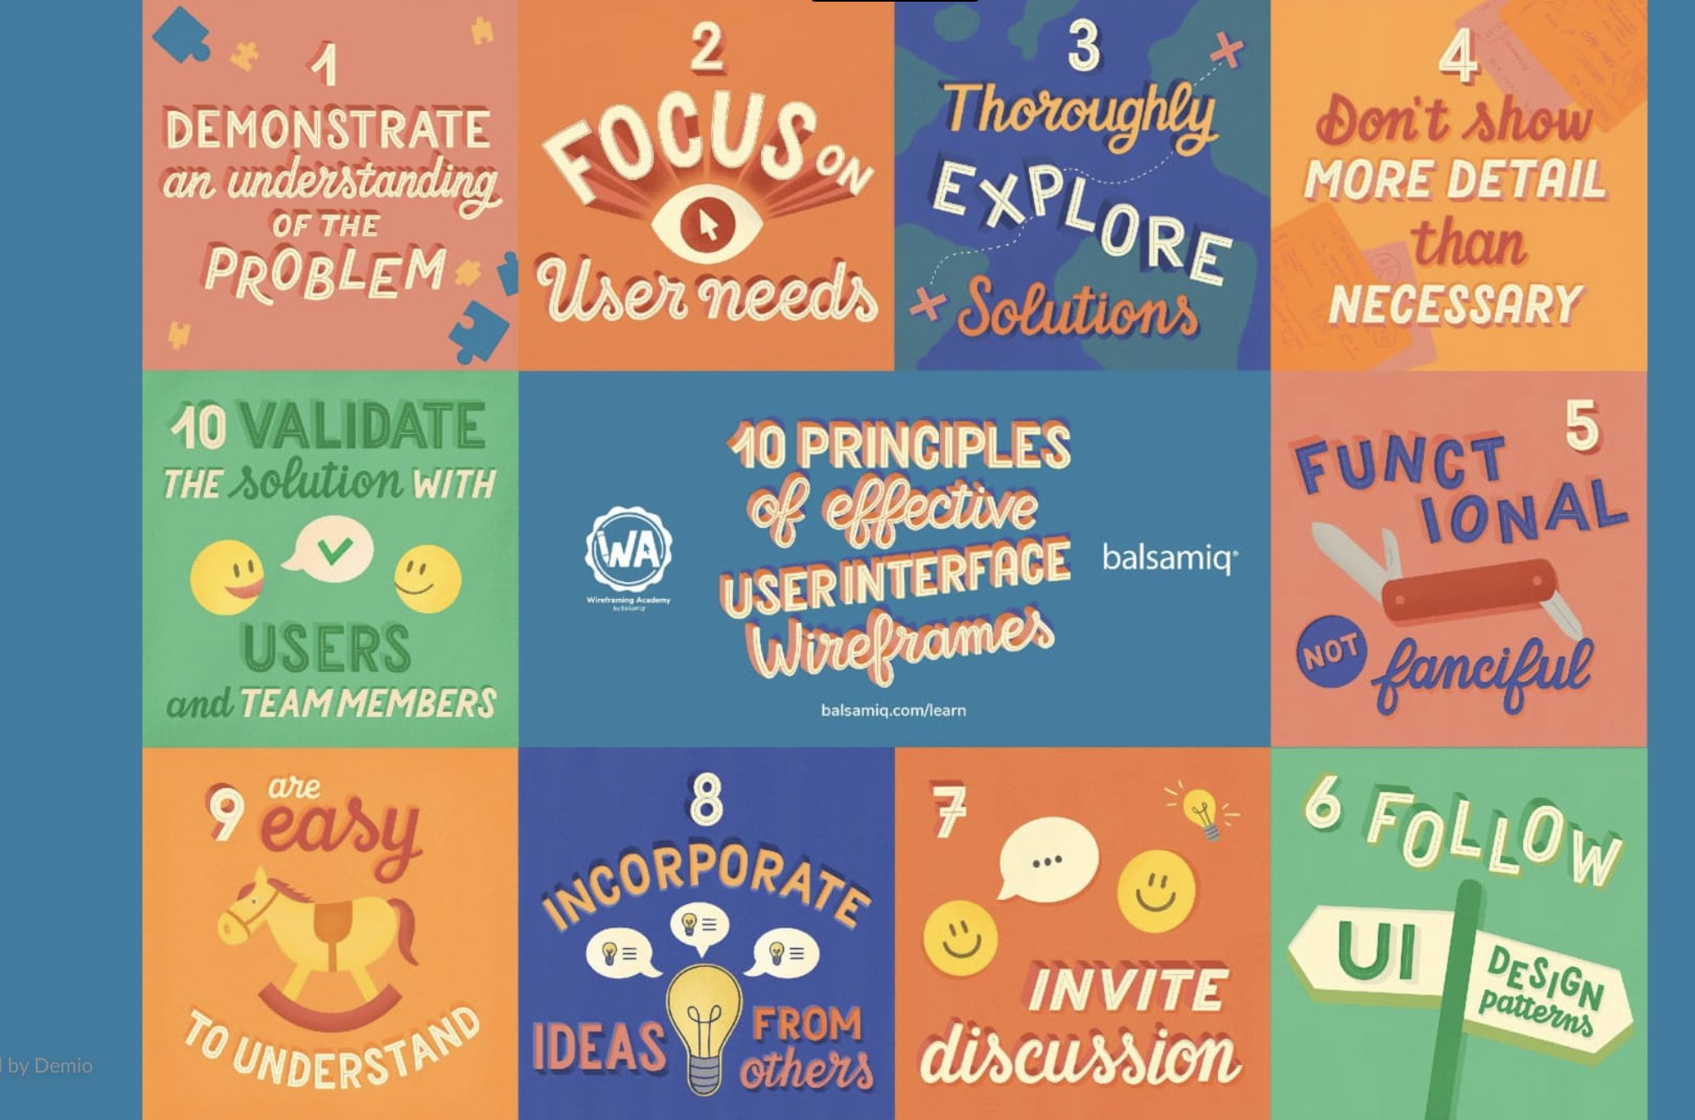
https://twitter.com/kevinklos/status/1353038740504064001?s=20

Article b. – Keyword “Loading Speed”
The previous question got me thinking about loading times for web pages, so after typing in “Loading Speed” I came across a Tweet from an account giving tips foe SEO. They go on to say that loading times aren’t necessarily about speed, but instead about loading speed perceived by the user. They go on to recommend the use of skeleton loaders to imitate the layout/structure of the webpage until the actual data is loaded. The idea being that the user sees something loading (that vaguely looks like what they’re expecting the page to look like), and psychologically they are thinking that the webpage is loading faster, even though the actual data might still take a few seconds.

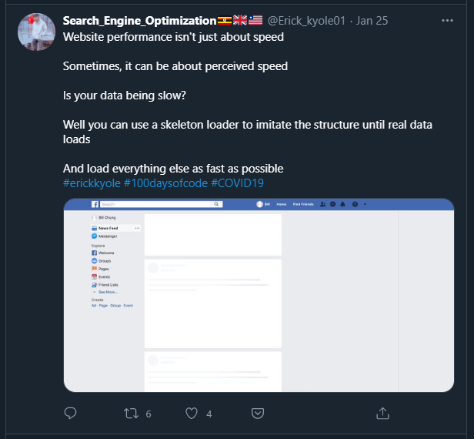
https://twitter.com/Erick_kyole01/status/1353721073699860480?s=20

  - Follow three people that could provide you with information during this module. Who are they? Why did you choose them?

Don Norman – Author of The Design of Everyday Things. I read this book a few years ago during my undergraduate degree in mechanical engineering and it lays out some fantastic design mistakes and good practices.
https://twitter.com/jnd1er?s=20

Sara Soueidan – Came across her when I searched for a “Web UI Design”, she seems to frequently post about anything to do with UI design and she has nearly 100,000 followers so she must know a thing or two.
https://twitter.com/SaraSoueidan?s=20

Steven Krug –Also came across him by searching for UI Design. Again, I don’t know much about him, but he has nearly 80,000 followers and seems to be well respected in the field
https://twitter.com/skrug?s=20

Part II – Starting Coding

Have a read of the following website: http://www.w3schools.com/html/html_basic.asp
Use the html tool http://www.w3schools.com/html/tryit.asp?filename=tryhtml_basic to do the following exercises:

- Display “Hello World” using HTML.

- Use header tags (<h1>-<h6>) in this web page.

- Illustrate the use of <a> (hyperlinks) in your web page.

- Introduce anchors (using <a>) into this web page. In doing this use the paragraph tag <p> and the line-break tag <br/> to format your text.

If you are coding in a text editor, the starting point for your html file should be this file - https://drive.google.com/file/d/1fuMydY72NMCIns4czJmLSkdO2ioiNVd9/view?usp=sharing

Part III – Analysing the UI (record in blog)

- Analyse the following websites with regard to usability in general (from your point of view)

https://www.tudublin.ie
Quite well laid out. I was very quickly able to find the information page for TU259 without actually knowing/typing in the course code. Just by clicking through to postgrad courses, then using the filters on the left of the page to show all computing full time courses.

All the information you might want about a course is shown clearly.

https://www.youtube.com/

All your options are very clearly presented here, with the sidebar showing the different sections you can go to (i.e. “Home”, “Trending”, “History” etc.). All sections are very self-explanatory from the title alone (maybe I am biased because I’m familiar with YouTube?). The web page automatically shows more videos as you scroll, which is very good for holding the user for a long time.

When I open this in an incognito window (as I’m signed into a Google account normally), the web page seems to notice that my Windows theme is set to dark and the web page is presented as a dark theme. (I’m not sure how this works exactly?) This is something I really do appreciate; I think dark mode should be the default colour scheme on all apps and pages.

https://www.udemy.com/
I really like the layout of their homepage. Within seconds of looking at it, it’s clear what your options are.

- Analyse all websites using this validator http://ready.mobi/
  - What did they look like?
  - How did they score?
  - What are the main problems with each of the three websites?

- Analyse the all websites using this tool http://wave.webaim.org/
  - How accessible are each of the three websites?
  - What are the problems in each of the three websites?
  - Are there similar problems in all three?

